Wynne, AR- June | Fayetteville, AR-September
Fort Smith, AR-July | Sheridan, AR-October
Russellville, AR-August | TBA- November/December
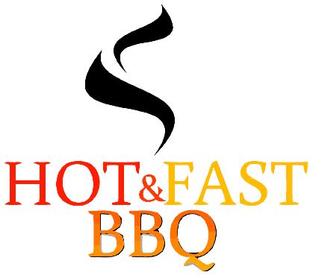
2016 Competition BBQ Sponsorship Agreement
Contact Information
Name of Corporation/Business: |  |  |  |  | Contact Person:
Address:
City: |  |  | State: |  |  | Zip:
Phone: |  |  | E-mail:
Sponsorship Level
I agree to be a Corporate/Business sponsor for the Hot and Fast BBQ Competition BBQ team at the following sponsorship level (select one):
☐ | Grand Champion-$600 | ☐ | Reserve Grand-$400 | ☐ | People’s Choice- $250 | ☐ | Individual Event- $100
 | SPONSORSHIP LEVELS DESCRIBED ON THE NEXT PAGE |  |  |  |  | (please indicate which event the in comments)
Logo Artwork Requirements:
For printed promotional materials EPS or outline vector file
For Website advertising .JPG/.PNG/.GIF
Payment Information
Payment Method:
 | ☐ | Check | ☐ | Credit Card
 |  | Make payable and mail to:  Hot and Fast BBQ  2015 S. Utica Avenue  Russellville, AR 72802 |  | If the invoice should be sent to a different email address than the one provided please enter it here:
Terms and Conditions:
Once payment in full is made, we will contact you immediately to satisfy the terms of the sponsorship agreement. The terms of this sponsorship are valid through December 31, 2016. If an event is cancelled, every effort will be made to find an alternate event. Email completed form to hotandfastbbq@gmail.com or mail it along with check payment. Thank you so much for your sponsorship!
Comments:
Signature: |  | Date:
Benefits of Sponsorship
Competitive BBQ is one of the most popular food trends in the country. There are contests all over the country and even internationally. The contests we plan to participate in will draw approximately 200 competitive BBQ teams from all over the country. Crowds will be in the thousands for several of these events and they are all KCBS sanctioned (the leading name in competitive BBQ). The cost for participating in competitive BBQ is high but the visibility is great for sponsors. I am attempting to secure sponsorships so that I can compete as frequently as possible. I would truly appreciate your sponsorship, and hope that you find it would be mutually beneficial for your business. I am happy to customize the tiers if some of the offers sound more beneficial for your business than others.
Sponsorship Levels:
Grand Champion- $600
- All of the benefits of “Reserve Grand” sponsorship, plus:
- Full size sponsorship banner (4’X6’) in place at all competitions for the calendar year
- T-Shirt from every event (or 5 t-shirts from the same event)
- Six jars of our award winning “Hot and Fast” Savory BBQ Rub
- Catered lunch for 12 (takes the place of the lunch for 6 from “Reserve Grand”)
Reserve Grand- $400
- All the benefits of “People’s Choice” sponsorship, plus:
- Option to have promotional materials placed at our competition space (flyers, pens, etc…)
- T-shirt from two events of your choice (or two t-shirts from the same event)
- Three jars of our award winning “Hot and Fast” Savory BBQ Seasoning
- Catered lunch for six (takes the place of the ribs from the “People’s Choice”)
People’s Choice- $250
- Logo placed on the Hot and Fast Competition Banner for the calendar year
- Website recognition in the sponsorship section of our website for the calendar year
- T-shirt from an event of your choice
- One jar of our award winning “Hot and Fast” Savory BBQ Seasoning
- Digital photos from the event showing your logo/promotional items
- Rack of our award winning baby back ribs
Individual Event- $100
- Prominent placement of your sign or logo during the competition you select to sponsor
- Website recognition in the month leading up to the event in the sponsorship section of our website
- T-Shirt from the event
- Promotional photo from the event
For Questions please call (479) 567-7800 or email hotandfastbbq@gmail.com . I look forward to representing your business at the next competition!

